# Ideation Phase

**Brainstorm & Idea Prioritization Template**

|  |  |
| --- | --- |
| Date | 19 September 2022 |
| Team ID | PNT2022TMID45109 |
| Project Name | News Tracker Application |
| Maximum Marks | 4 Marks |

Brainstorm & Idea Prioritization Template:

Step-1: Team Gathering, Collaboration and Select the Problem Statement

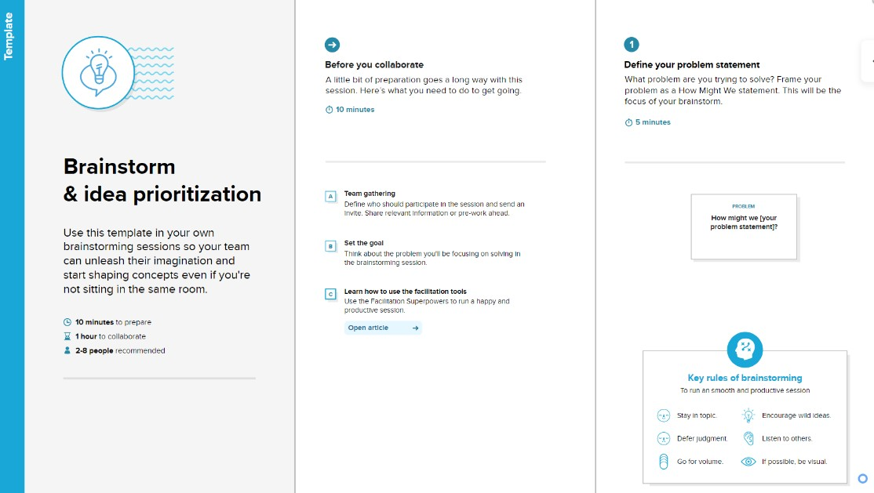

**Step-2: Brainstorm, Idea Listing and Grouping**

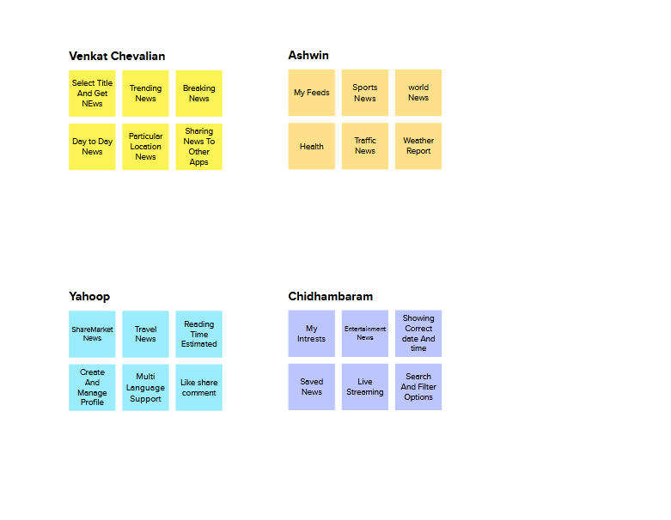

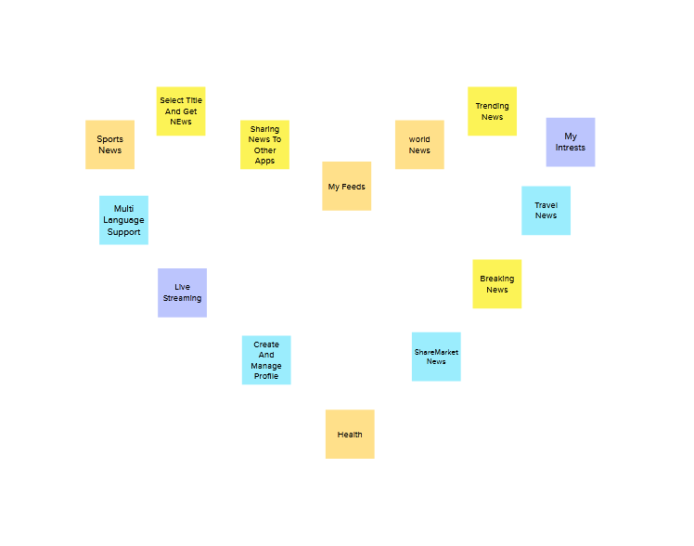

**Step-3: Idea Prioritization**

